|  |  |  |  |
| --- | --- | --- | --- |
|  |  | **WORKSHEET - 3** | |
| **Class: CSE30B** | | **Group No.: 8** | |
| **Group Members Details** | |  |  |
|  |  |  |  |
| **S. No.** | **Name** |  | **UID** |
| **1.** | **Sandeep Kumar** |  | **20BCS4885** |
| **2.** | **Shivangi Pathak** |  | **20BCS4886** |
| **3.** | **Yogesh Choudhary** |  | **20BCS4887** |
| **4.** |  |  |  |

**Task:** Design a Cloud based weather monitoring system using IoT platform and relevant sensors.

**Requirements:**

* PC with Arduino
* Connecting Wires
* Breadboard
* DOIT ESP32 DEVKIT V1
* 10uF Electrolytic Capacitor
* Wire Clipper
* USB Type A to Micro USB Cable
* DC 5V Power Supply
* DC 3.3V Power Supply
* BMP280

**Theory:**

For a long time weather monitoring was largely a pastime of enthusiastic amateurs, but over the last century it has evolved into a well organised and professional global activity that reflects its crucial importance for a wide range of economic, environmental, civil protection and farming activities. Weather variables such as wind speed and direction, air temperature, humidity and rainfall may all be important factors in determining the course of a wide range of events. For example, agriculture has always been heavily dependent on the weather and weather forecasts, both for its control on the quality and quantity of a harvest.

**Circuit Diagram:**

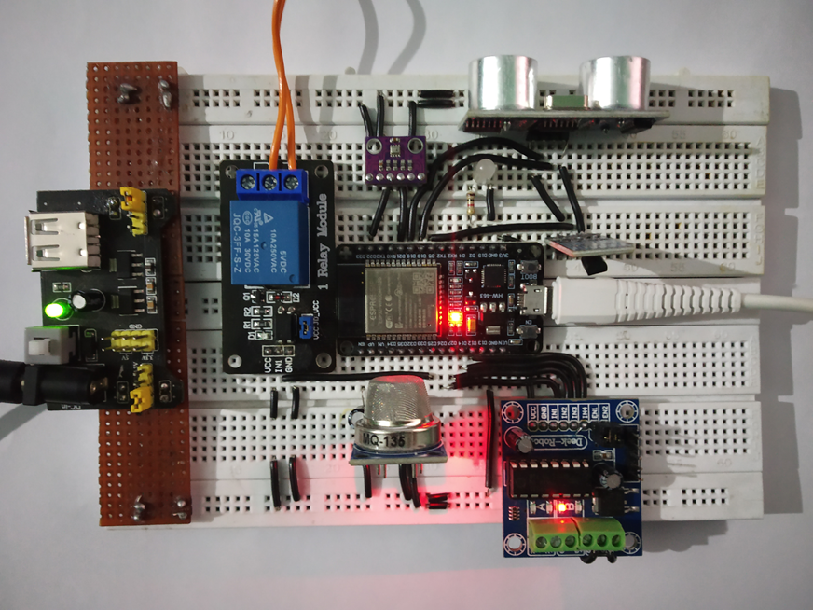

**Code (if any):**

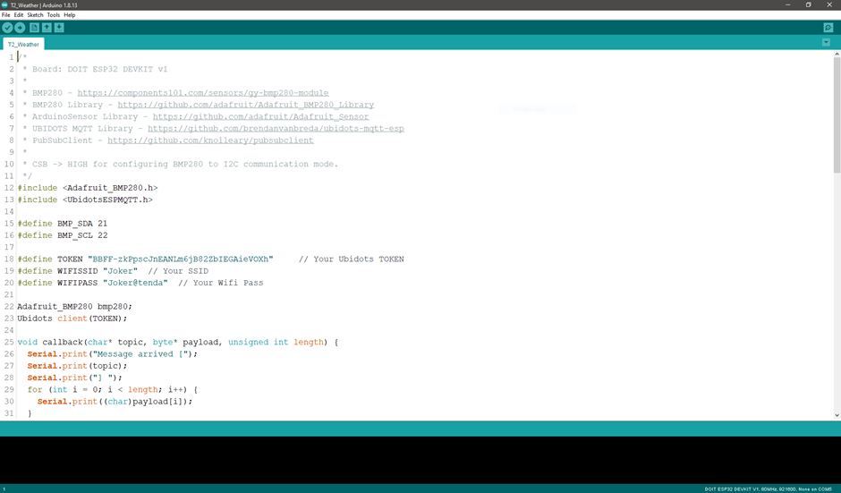

**Dashboard Snippet (if any):**

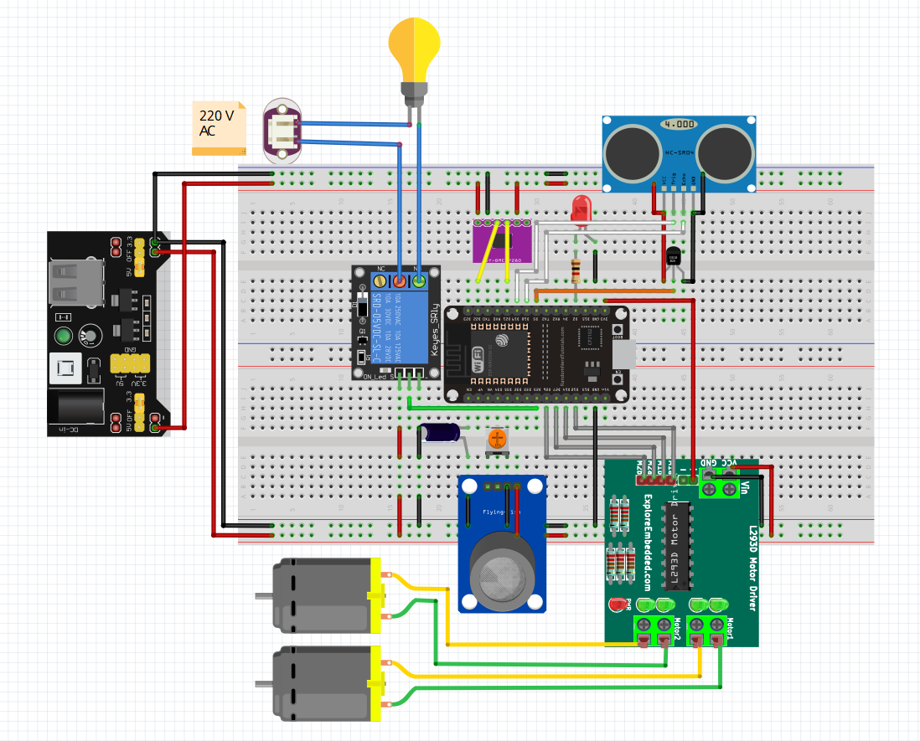

**Outcome:**

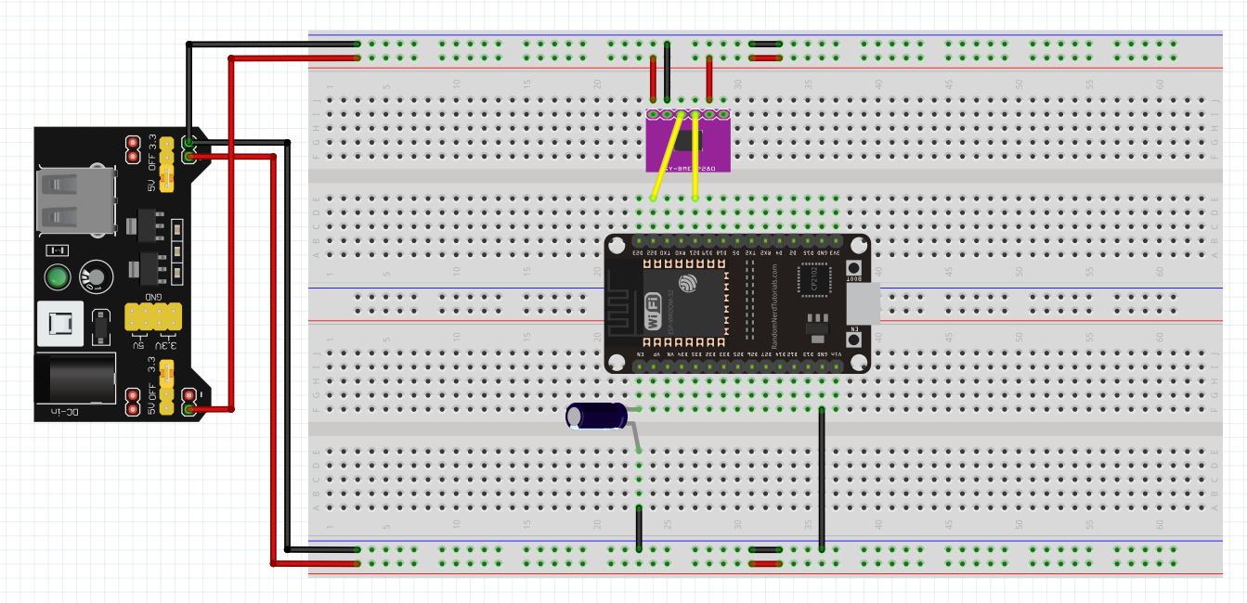

* Learnt to implement simulation on Fritzing application.
* Learnt about operating Arduino UNO using simulation software.
* Coding to delay the Led on and off is also been learned during this practical

**EVALUATION COLUMN (To be filled by concerned faculty only)**

|  |  |  |  |
| --- | --- | --- | --- |
| **Sr. No.** | **Parameters** | **Maximum** | **Marks** |
|  |  | **Marks** | **Obtained** |
|  |  |  |  |
| 1. | Post Lab Quiz Result. | 5 |  |
|  |  |  |  |
| 2. | Worksheet completion including writing | 10 |  |
|  | learning objectives/Outcomes. (To be |  |  |
|  | submitted at the end of the day) |  |  |
|  |  |  |  |
| 3. | Student Engagement in | 5 |  |
|  | Simulation/Demonstration/Performance |  |  |
|  | and Controls/Pre-Lab Questions. |  |  |
|  |  |  |  |
| 4. | Total Marks | 20 |  |
|  |  |  |  |